# **EXPLORE WEATHER TRENDS**

1. ***Outline:***

* *Tools used for each step:*

1. **SQL Queries and Udacity workspace to extract the data from the database: -**

***1. SELECT * FROM global_data;***

***2. SELECT city FROM city_list WHERE country = ‘India’;***

***3. SELECT year, avg_temp FROM city_data WHERE country = ‘India’ and city = ‘Pune’;***

1. **MS Excel to calculate the Moving Average and create Line Graph.**

* *Calculating moving average:*

**Calculated the moving average by typing the formula: *average(cell2:cell13)*, then dragging down the MA cell till the last temperature value.**

* *Key considerations while deciding to visualize trends:*

**To observe the difference in global and local temperature and also their individual temperatures to note down short term and long term trends for further analysis.**

1. ***Line Chart with local and global temperature trends:***

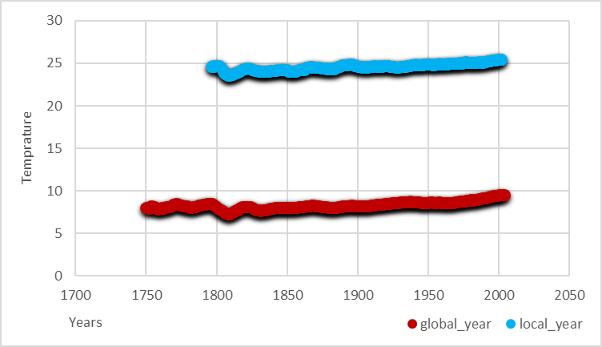

***3.Observations:***

* *Local temperature average is roughly 4x higher than global temperature average.*
* *Both the graphs have a slight increase in the average temperature over long term.*
* *Both the graphs are observed to be vacillating over short periods.*
* *The rate of increase in global temperature moving average is slightly higher than that of local’s over a longer period of time.*